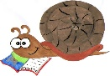
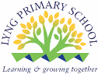
Lyng Primary School Knowledge Organiser

History Topic: | What were children’s lives like during the Victorian era? | Year 4  Buildings, Battles and Beliefs | Spring/Summer
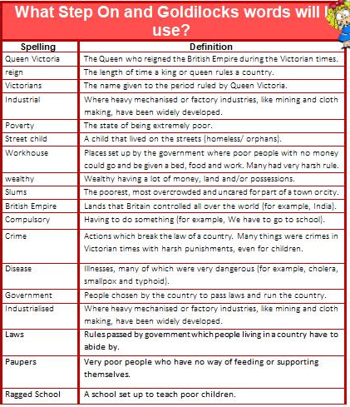

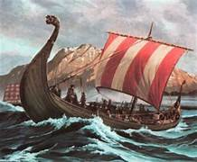
Let’s recap…
- Year 1 – Children learn about how toys have changed across the different eras.
- Year 2 – Children learn about how the life of Victorian children who lived in the Black Country has changed.
- Year 3 – Children learn about a range of eras and how they lived.


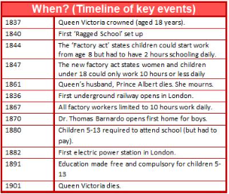
HOOK - Street Child
A Victorian Street child is trying to flee the workhouse and our children explore why.
TRIP/VISITOR
Blists Hill Victorian Town

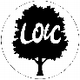
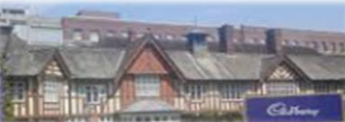
To discover more:
BBC Bitesize – https://www.bbc.co.uk/bitesize/articles/zkb6fdm
School learning zone – School Learning Zone - The Victorians

Our Storytelling Approach to enhance engagement

People:  Street Child | 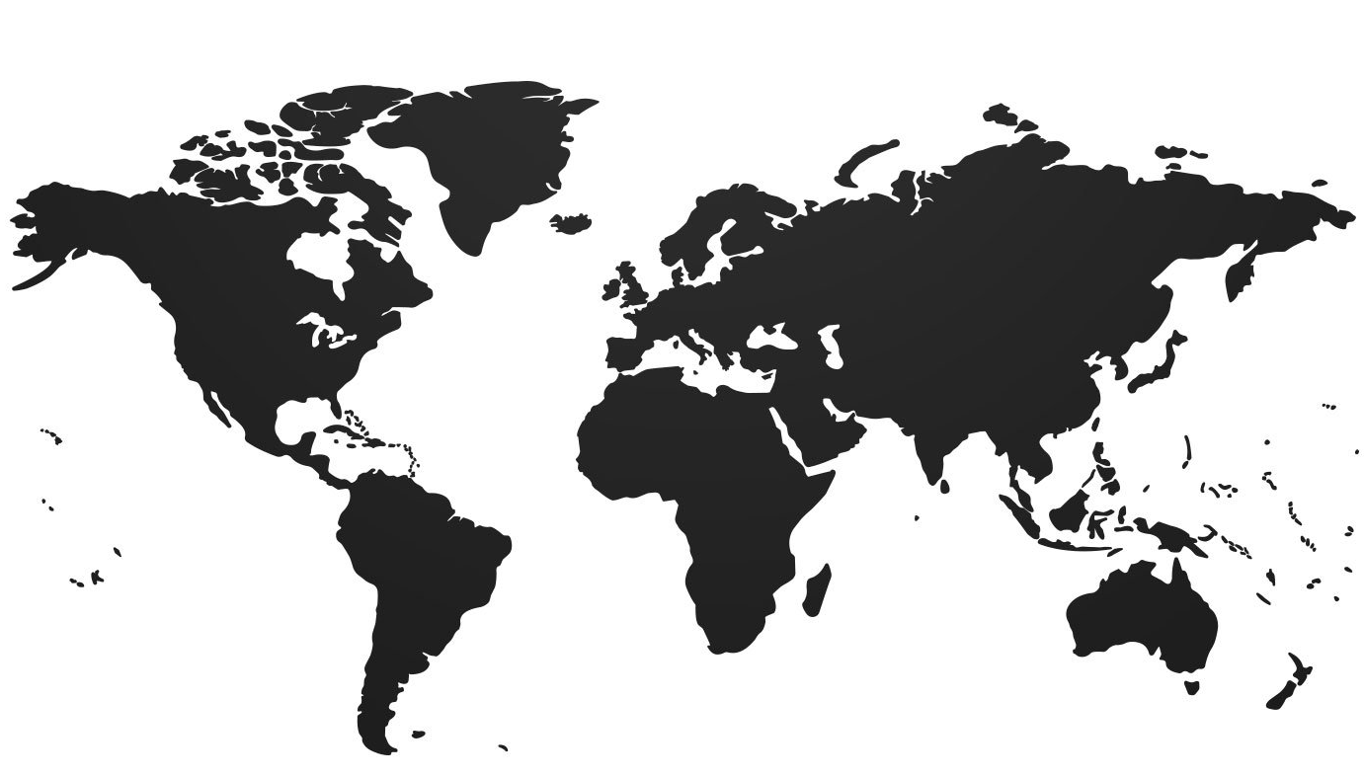Place:  The Slums | Problem:  How do I get out of the workhouse?
Focus Text
Key Facts and Famous Figures
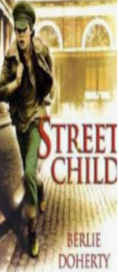
Queen Victoria was the Queen who rules during the Victorian era.
John Cadbury was the founded of the brand Cadbury, who opened a factory for the production of chocolate and changed the lives of his workers.
William Morris a designer and artist who was very popular in Victorian time.
Dr. Thomas Barnardo was a missionary who set up homes for poor, homeless children with food, shelter and training. Rescued around 60,000 children.
Florence Nightingale a wealthy lady who travelled to the Crimean War to nurse dying soldiers. Responsible for the birth of nursing.
Joseph Lister was a scientist who invented antiseptics which killed germs.
Louis Pasteur was a scientist who discovered that wounds became infected because of invisible germs and bacteria.
Mary Seacole was a Jamaican lady who travelled to the Crimea war to nurse soldiers, even on the battlefield.

Enquiry questions (sequence of learning) that we shall investigate during the topic:
- What key events occurred during the Victorian Era?
- Who was Lord Shaftesbury and was he influential?
- What was the impact of Britain on the World?
- What did we learn at Blists Hill?
Agreed Outcome
To understand the battles and struggles that Victorian children faced.

Lyng Primary School Knowledge Quiz

History Topic: | What were children’s lives like during the Victorian era? | Year 4  Buildings, Battles and Beliefs | Spring/Summer
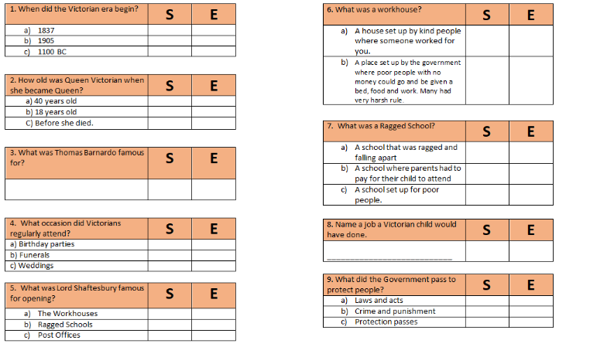

Our Victorian
Quick Quiz

